Section 1: Case Summary

Scenario Title: | STEMI and VF Arrest (ECMO Case)
Keywords: | STEMI, Ventricular Fibrillation, Cardiac Arrest, ECMO
Brief Description of Case: | Ronda is a 50 yo female who flew back from Korea the day before and started to experience chest pain, dizziness and SOB today. On EHS arrival the patient’s initial ECG and vitals were normal but she proceeded to have a witnessed vfib arrest. With defibrillation and epinephrine the patient obtained ROSC but then went into a PEA arrest. On ED arrival the patient is in ongoing PEA arrest 25 minutes after initial time of witnessed arrest. The team will need to continue ACLS for PEA arrest, recognize ECMO activation criteria is met and activate the ECMO team. ICU ECMO team will be involved to cannulate patient. She will end up having a STEMI, with a successful cath for a significant LAD lesion.

Goals and Objectives
Educational Goal: | To practice ACLS for PEA arrest, review ECMO activation criteria and the process of ECMO activation. Support ICU ECMO team in initiation of ECMO.
Objectives:  (Medical and CRM) | - Recognize pre-hospital that ECMO criteria is met  - Effective team preparation for critically ill patient in PEA arrest  - Demonstrate effective communication and resource allocation in an ECMO activation  - Steps to prepare for ECMO by ED team  - ACLS PEA arrest management
EPAs Assessed: | N/A

Learners, Setting and Personnel
Target Learners: | ☐ Junior Learners |  | ☐ Senior Learners |  |  | ☒ Staff
 | ☒ Physicians | ☒ Nurses |  | ☒ RTs | ☒ Inter-professional
 | ☒ Other Learners: ICU ECMO team
Location: | ☐ Sim Lab |  | ☒ In Situ |  |  | ☐ Other:
Recommended Number of Facilitators: | Instructors: 1
 | Confederates: 0
 | Sim Techs: 1

Scenario Development
Date of Development: | April 10/2024
Scenario Developer(s): | Chantal McFetridge (FRCPC EM)
Affiliations/Institutions(s): | UBC
Contact E-mail: | Chantal.mcfetridge@gmail.com
Last Revision Date: | April 10, 20204
Revised By:
Version Number: | 1

Section 2A: Initial Patient Information

- Patient Chart
Patient Name: Ronda Smith |  |  |  | Age: 50 | Gender: F | Weight: 70 kg
Presenting complaint: Chest pain
Temp: 36.8 ºC | HR: PEA arrest | BP: n/a |  | RR: 12 BVM via SGA | O₂Sat: 98% | FiO₂: 100%
Cap glucose: 7 mmol/L |  |  |  | GCS: 15 (E4 V5 M6 )
Pre-hospital notification: 50 y/o previously healthy F returned from Korea yesterday, with chest pain, dizziness, shortness of breath today. With EHS patient was initially vitally stable, but had a witnessed vfib arrest with ROSC from 3 rounds of CPR/epinephrine and defibrillation. Unfortunately deteriorated after a few minutes into PEA and has been in PEA since. Unable to obtain pre-hospital IV access, 1 pre-tibial IO. Time since initial arrest is 15 minutes. Crew is 10 minutes out from ED.

Allergies: NKDA
Past Medical History:  Healthy |  |  | Current Medications:  None

Section 2B: Extra Patient Information

A. Further History
Include any relevant history not included in triage note above. What information will only be given to learners if they ask? Who will provide this information (mannequin’s voice, confederate, SP, etc.)?

Patient (mannequin’s voice) gives following information if asked by learners:
As above
Patient is in arrest and cannot provide further history
B. Physical Exam
List any pertinent positive and negative findings
Cardio: Ongoing CPR | Neuro: Pupils are 3+, sluggish but reactive
Resp: Igel insitu, AE decreased to bases, no crackles or wheezes | Head & Neck: normal
Abdo: soft, no rigidity | MSK/skin: dry, normal
Other:nil

Section 3: Technical Requirements/Room Vision

A. Patient
☒ Mannequin (specify type and whether infant/child/adult) – adult, computerized mannequin
☐ Standardized Patient
☐ Task Trainer
☐ Hybrid
B. Special Equipment Required
PPE: gown, N95 mask, gloves
Defibrillator and pads
LMA - igel
Intubation materials
Access – IV/IO
ECMO cannulation equipment
C. Required Medications
ACLS medications
D. Moulage
E. Monitors at Case Onset
☐ Patient on monitor with vitals displayed
☒ Patient not yet on monitor
F. Patient Reactions and Exam
Include any relevant physical exam findings that require mannequin programming or cues from patient
(e.g. – abnormal breath sounds, moaning when RUQ palpated, etc.) May be helpful to frame in ABCDE format.
A – Airway – Igel insitu
B – BVM through igel, decr air entry bilaterally to bases, no crackles or wheezes on auscultation. No cyanosis.
C – Extremities cool. Pulseless.
D – In arrest. PEARL 3+, sluggish.
E –No signs of trauma or injury on head-to-toe examination.

Section 4: Confederates and Standardized Patients

Confederate and Standardized Patient Roles and Scripts
Role
Charge RN
Patient

Section 5: Scenario Progression

Scenario States, Modifiers and Triggers
Patient State/Vitals | Patient Status | Learner Actions, Modifiers & Triggers to Move to Next State |  | Facilitator Notes
Pre-hospital  Witnessed arrest 15 min prior to EHS pre-notification, ETA ED arrival 10 min  Rhythm: PEA  HR: Arrest  BP: N/a  RR: 12 (BVM)  O₂SAT: 98%  T: 36.8ºC | Pre-hospital notification & Preparation | Expected Learner Actions  Team pre-brief – roles, equipment, meds  Activate ECMO  Don PPE & name/role tags  Obtain / set up lucas |  | ECMO activation criteria:
2. PEA Arrest – ED arrival & Initial Mgmt  Rhythm: PEA  HR: --  BP: --  RR: -- | Pt unresponsive and pulseless, PEA on monitor | Expected Learner Actions  Place cardioresp monitors and pads  Activate ECMO – if not done  Initiate CPR – apply lucas  Obtain IV access (or IO)  Epinephrine q3-5 min  Change LMA ETT | Modifiers  - Rhythm check PEA, patient remains in arrest throughout whole resuscitation  Triggers  N/a
3. VF Arrest – ECMO Preparation  Rhythm: VF  HR: --  BP: --  RR: -- | Pt unresponsive and pulseless, PEA arrest | Expected Learner Actions  Ensure lucas placed  Abort further pulse/rhythm checks unless clear signs of life  Stop epi after max 5 mg  Request 2 units blood bank  Draw up heparin 5000 IU  Ensure patient undressed  Prep and drape both groins  Prepare 2 U/S w/sterile cover  Prepare 2 CVC trays, can consider placement fem CVC if timing allows | Modifiers  - Rhythm check PEA  Triggers  N/a
4. ECMO Cannulation  Rhythm: PEA  HR: --  BP: --  RR: -- | Pulses present  GCS 2T | Expected Learner Actions  ICU team arrival and initiation of cannulation  Prepare for transfer to ICU | Modifiers  ICU calls and is ready for patient transfer  Triggers  Patient is successfully cannulated on ECMO -> END CASE

Appendix A: Laboratory Results

Labs will not be back before the case ends.

Appendix B: ECGs, X-rays, Ultrasounds and Pictures

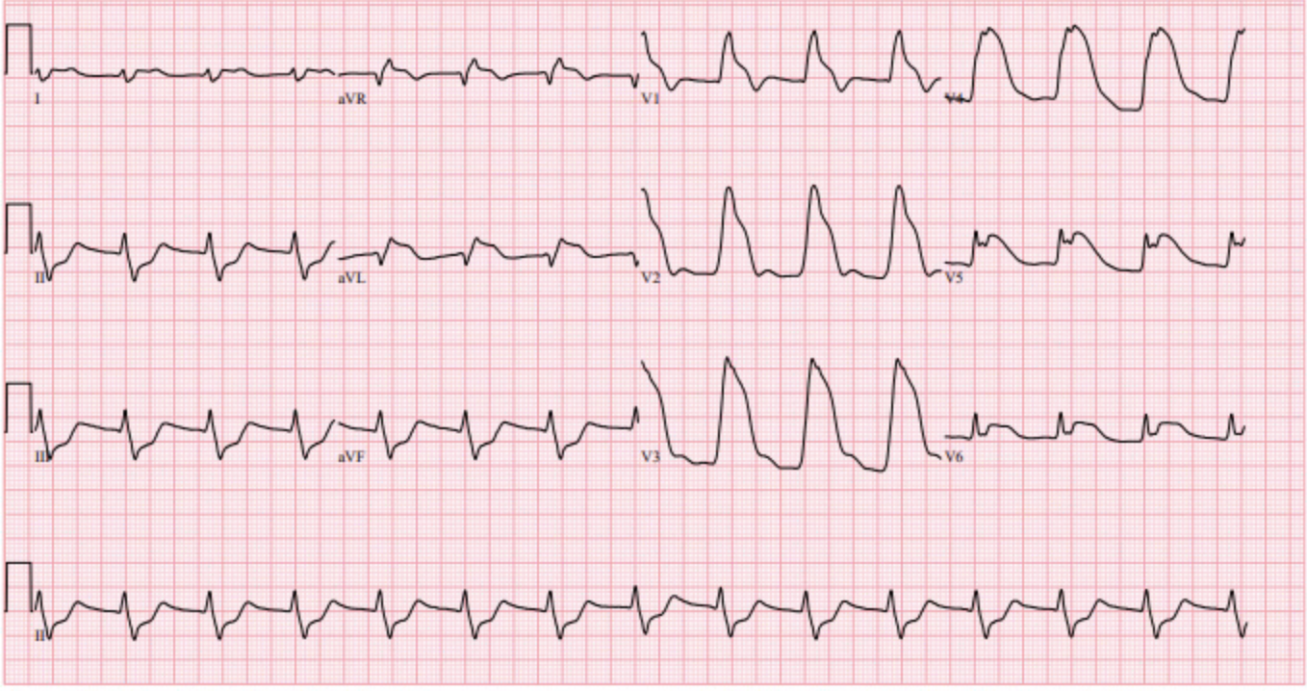

Appendix C: Facilitator Cheat Sheet & Debriefing Tips

ECMO Activation Criteria (RCH) – as of April 2024

Objectives:
- Recognize pre-hospital that ECMO criteria is met
- Effective team preparation for critically ill patient in PEA arrest
- Demonstrate effective communication and resource allocation in an ECMO activation
- Steps to prepare for ECMO by ED team
- ACLS PEA arrest management

Positives:

Areas of Improvement:

Sample questions for debriefing:
- Consideration of pre-hospital activation of ECMO
- Transition of leadership when ICU ECMO team arrives
- Preparation for ECMO my ED team and alterations to standard ACLS
- Challenges specific to ECMO initiation in ED

References

