Site: RCH |  |  | Location: Emergency CT Trailer
Date: May 15, 2024
Facilitator(s): Abby Holder, Ali Abdalvand, James Beaudoin |  |  | BCSMS #: Sim Use Only
Area of Process SIM: Transfer patient from Emergency Department (trauma bay) through the ISB to the temporary CT Trailer

Objectives: Identify potential issues/concerns and strategize ways to adjust and make the event of patient transfer successful; examine path of travel from Emergency Department (Trauma Bay) to CT Trailer.

What healthcare disciplines and/or public partners are required? | ☒ Nursing | ☒ Physicians |  | ☐ Unit Clerk | ☒ RT
 | ☐ Nursing Students | ☐ Medical Imaging |  | ☐ Lab | ☐ Medical Students
 | ☐ Residents | ☐ OT/PT |  | ☐ Volunteers | ☐ Registration
 | ☐ Project Management team | ☐ Ergonomics team |  | ☐ CNE / PCC | ☐ Corrections
Other participants: Care Aids to help with transfer

Post Process Simulation Log
Impact/Risk | Priority Ranking |  | Description
Impact | High Impact |  | Frequent Event
 | Medium Impact |  | Intermittant Frequency
 | Low Impact |  | Rare Event
Risk | High Risk |  | If fails, risk for significant patient harm
 | Medium Risk |  | If fails, possibility of minor patient harm/delays in care that is  likely to be detected
 | Low Risk |  | If fails, unlikely to result in harm/delays and likely to be caught
System Issue Analysis Log: Environment, Supplies, Time, Patient Safety, Staff
Identified Issue/Areas for Discussion |  | Discovery items & Description |  | Suggested or Required Actions | Role assigned to action item | Priority Ranking (impact & risk)
Transfer Time |  | - Estimated total transfer time (Emerg/CT Trailer/Emerg): 15 mins  - From Emerg to CT Trailer: approximately 5 mins (round to 7 mins)  - From ISB main doors to CT trailer (uphill): 2 mins and 30 secs  - Getting into CT Trailer doors and lower rails: 40 secs  - From CT Trailer back to Emerg : approximately 5 mins (round to 7 mins)  - Note: acknowledge time was not taken into account for transferring patient from stretcher to CT bed and actual CT scanning time |  | - Use of Red Trauma Stretcher with rails down to facilitate efficient flow of transfer
Patient Safety: Weight |  | - No slings/scales present in CT Trailer  - No weight for hot stroke patients |  | - Take weight of patient prior to CT Trailer arrival
Patient Safety:  Stabilization in constricted space |  | - Patient’s head needs to align with CT Scanner’s bed and requires sufficient leg room |  | - Stabilize lower extremities (i.e. splints) prior to patient arrival in CT Trailer to ensure adequate leg spacing when transferring patient to CT Bed from stretcher  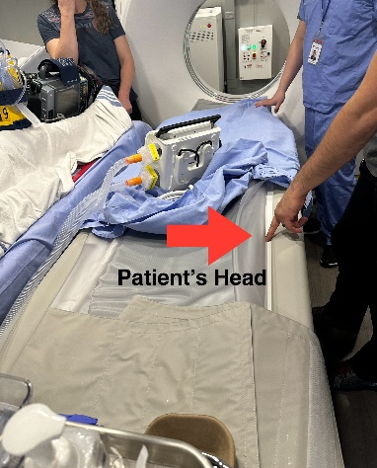
Restrictions |  | - Tight space allowed for patient with ventilator, pleur-evac, and lifepak on stretcher – IV pump was also present |  | - Avoid use of big equipment in transfer (ie. rapid infuser/fluid warmer) Belmont/Ranger  - Consider pressure bagging patient if required
Physician Support |  | - Importance of physician presence |  | - Consider physician staying with patient for the duration of transport
Swipe/ID card access to linen doors |  | - Access to linen doors – CT Trailer staff does not know at the moment if access is always present to emerg staff -  - Medical imaging can help open linen doors when exiting CT Trailer  - During the sim process itself, doors happened to be open |  | - Connecting with appropriate staff to ensure care aids and staff responsible for transfer have adequate access (after hours access in particular & usual business hours)
Portable Suction |  | - Importance of suction presence |  | - Consider bringing an additional portable suction
O2 tanks |  | - 3 Oxygen tanks available in CT Trailer at present time
Crash Cart |  | - 1 Crash Cart present in CT Trailer and is checked/maintained regularly by CT Trailer staff
Power Bar |  | - Extra power bar available with no extension cord in CT Trailer  - Power outlets present by entrance door but in use currently  - Next available power outlets are behind CT machine |  | - Consider placing a power bar with extension cord in CT Trailer to act as an extra technological resource
Signage/Wayfinding |  | - Concerns regarding navigation to CT Trailer in ISB Corridor |  | - Consider adding more signage in ISB Corridor
Use of Stretcher Transport Equipment |  | - Equipment is in maintenance and not working  - Porters do not transfer trauma patients |  | - Use of this specific transport equipment requires training that Care Aids do not currently have

