What’s happening?  
  
FHVC (Fraser Health Virtual Care) provides post-discharge follow-up calls for referred acute and emergency department (ED) patients within 24-72 hours after their discharge.   
**Starting June 3rd they will connect with mBIG patients post-discharge if referral is entered**

Why?  
  
Many patients and families do not retain the discharge instructions provided, or realize they have questions after discharge. By providing a follow-up call, the FHVC RN will reiterate and clarify discharge instructions and provide patients an opportunity to ask questions and confirm understanding. They will also guide patients to appropriate follow-up when indicated.

How do I refer a patient?  
  
Submit a *Virtual Care Referral* via a Meditech Order Entry (see screenshot below).  
**Include a note in the comment section that patient is mBIG**.   
This comment will trigger FHVC to prioritize these referrals.

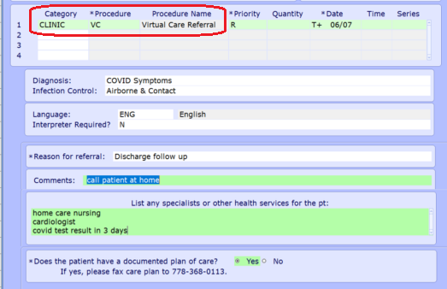

Prior to discharge:

1. Ensure the patient’s/caregiver’s telephone # in Meditech is accurate
2. Tell the patient/family that they will get a follow-up phone call from the FHVC team
3. Ensure that someone will stay with the patient for the first 24 hours, and
4. Provide discharge teaching (see next page)

Discharge teaching:

**Continued concussion symptoms are normal**. Advise patients/family to seek reassessment if the patient:

* can not be fully woken up, has trouble waking from sleep or staying awake
* is acting confused or disoriented
* has a sudden/persistent change in behaviour
* cannot walk normally
* is having trouble speaking/slurred speech
* has severe weakness, cannot move an arm/leg or one side of the face/body feels numb
* has double vision or worsening vision
* has blood or liquid draining from ears or nose
* or has **worsening** (despite rest and use of appropriate medications):

headache

nausea or ongoing vomiting  
dizziness  
focus/concentration/memory

Follow up

For acute symptoms please direct patient to follow up in their local ED. For less urgent changes, or lack of improvement in symptoms patients should be directed to follow up with their GP or a UPCC or clinic.

Info on FHVC

Referrals for discharge follow up phone call from FHVC can be submitted for any patient discharged from hospital or ED who you believe may benefit from a follow-up connection with an RN. Eligible patients must be discharged **to home**, have a working phone number, and are not under the care of another community follow-up service (e.g., Home Health, MHSU).

Patients are called by FHVC as soon as 24 hours after discharge. The discharge summary is used to understand the plan of care to inform the questions asked. Please ensure discharge dictation is completed within 24 hours.

For more information

For Fraser Health Virtual Care services questions regarding this expansion of services, please contact: [abigail.holder@fraserhealth.ca](mailto:abigail.holder@fraserhealth.ca), [sonia.jose@fraserhealth.ca](mailto:sonia.jose@fraserhealth.ca) or [minetaro.naruki-vanvelzen@fraserhealth.ca](mailto:minetaro.naruki-vanvelzen@fraserhealth.ca)