October 24-30th is RT week in Canada.
Please take time next week to celebrate these amazing health care professionals!
If there is one good thing about this pandemic it has brought us all closer together as a team, and the RT’s are a big part of that…
Happy RT week!
We have some ED Fit testers, but their capacity to do this is limited.
Please try to book a fit test appointment at the link below. If you have been assigned an Elastomeric half mask respirator please bring with you for a re test as well.
https://pulse/work-essentials/health-safety/Pages/Fit-Testing.aspx
- At the onset of COVID-19, WorkSafeBC temporarily extended the fit-test frequency requirement from 1-year to 2-years for N95 respirators. Effective June 25, 2021, the 1-year fit-test frequency requirement is back into effect.
The Elastomeric respirators will continue to be the standard choice in our department but the original 3 N95 masks (1860 1860small 8210 and 1870+) will be required to be fitted as well. Alternates such as the 1511 1804 1804small will be phased out.


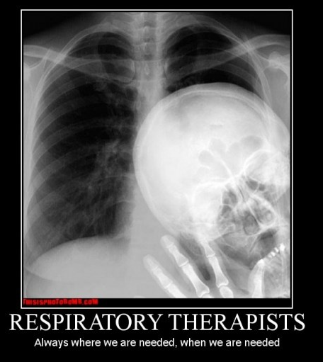
Annual Fit Testing
ROYAL COLUMBIAN HOSPITAL (RCH) - STAFF INFLUENZA VACCINE CLINICS
All Staff, Physicians, Volunteers, Students and Selected Contractors are welcome!

Book your flu shot online: Click Here to Book Online!
https://urldefense.proofpoint.com/v2/url?u=https-3A__outlook.office365.com_owa_calendar_FHAClinics-40mtcad.onmicrosoft.com_bookings_&d=DwMFAw&c=6c8DIriZkJJjEzDlEHg4pTfR83wWvI-L5gxS0uxob8g&r=pD9duI5de9YtqTRP7E-4brbbbhcXcW7OB38TogREKx0&m=05FgEL-QPX2W1avcKosKWxwdfqqaui8DzVefwwIBlJg&s=l8BjJiI_x1LNULy6R7Pp_uLvN5uA-ebU15e1eLoH9qE&e=

Please use Chrome and not Internet Explorer to make the booking

Please arrive on time for your appointment and bring the following items:
- Medical Grade Mask
- BC Services Card
- Completed Consent Form

We have some peer nurse immunizers in the ED, but we are all pretty stretched right now.
Please book your flu shot through the link below if possible.
If we get more capacity we will offer flu shots to staff in the ED.




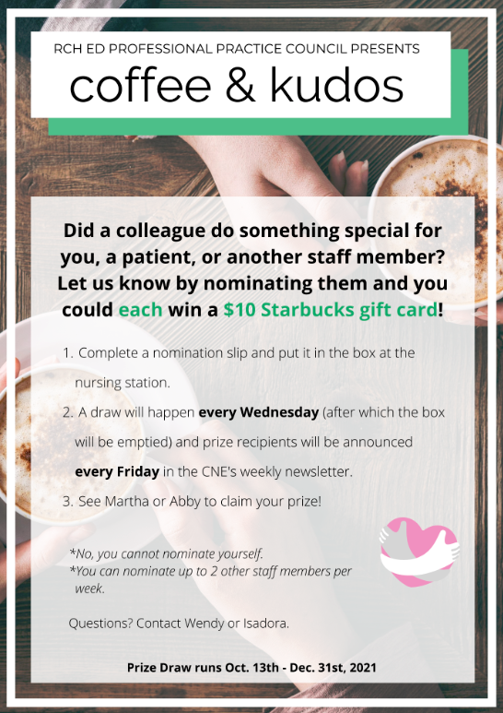

Kudos Corner
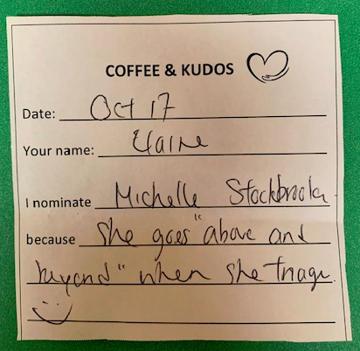
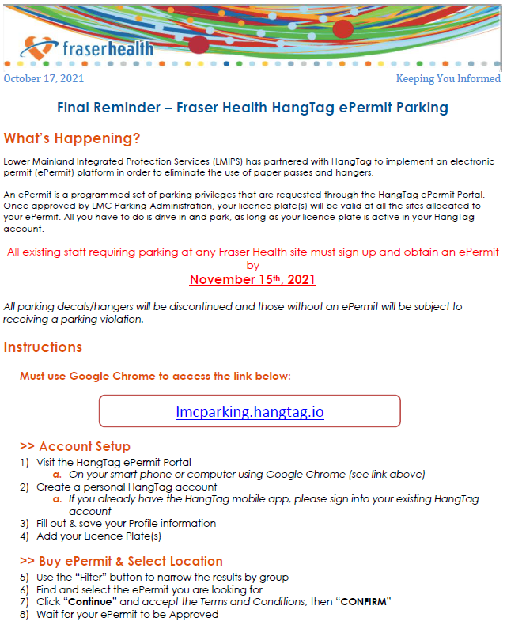
Fraser Health Executive are looking for suggestions on how we can attract and keep staff in the ED, knowing that most of our EDs are dealing with a staffing crisis. If you have any suggestions, please send them to Martha and Abby and we will forward to the regional CNSs’ who will take to the committee tasked with working on this. Some things might not be possible (i.e. increased pay or higher shift differentials because these things are union issues) but no harm in asking…
For me, safe staffing ratios and fixing parking were at the top of my list, but all suggestions, especially innovative ideas, will be considered.

ED Staffing Crisis
MARs
Remember to transcribe your medications from Dr Order sheet to the MAR. There have been a few situations lately where medications have been noted on the Dr Order sheet with “MAR” yet not transcribed onto the MAR. Also remember that our Unit Clerks will transcribe our medications onto MARs but the nurse is responsible for checking that the transcriptions are accurate.

2 Patient Identifier
With how busy and congested the department has been please ensure you are using 2 patient specific identifiers cross referenced with the corresponding documentation. Patient identifiers are: full name, birthdate, client stated home address, PHN on care card/DL, government issued photo ID, health authority armband. Both patients and substitute decision makers can respond verbally to confirm identification.
Unacceptable client identifiers
Bed, station or room number
Name on bed, mobility devices, clothes or accessories
Home address on documentation that is not confirmed by the client

PRBCs
When you have issues with a bag of PRBCs, or any blood products such as the bag has clotted off, discoloration of the product, damaged product, please send the entire product back to TML, including any tubing that may be attached to the product. Also fill in a PSLS as this could be as safety concern for other patients that could be avoided if brought to attention.
Pink tags must remain attached to the PRBC bag until fully administered.

BCI feasibility study – Start TBA. Forms will be on Orange paper and kept in trauma room
This is a feasibility study looking at the logistics of doing a large scale prospective cohort study (possibly at multiple sites). It will be conducted at RCH ED. We are interested in assessing the trends of hs-troponin in patients with blunt chest injury and how this will help in establishing the diagnosis of blunt cardiac injury

Inclusion criteria
1. Age > 18 years and Diagnosis of blunt thoracic trauma
Exclusion Criteria
1. Not admitted to hospital under TTL
2. Penetrating chest injuries
3. Known history of cardiovascular disease including previous myocardial infarction and/or congestive heart failure
4. Patients dead on arrival
5. Patients transferred from other facilities
6. Inability to obtain informed consent from patient or temporary substitute decision maker
7. Currently enrolled in any other research study involving drugs or devices
HsTrop will be ordered at 0, 8 and 24 hours to assess whether this is useful in Dx of blunt cardiac injury

Regional PPO for Sepsis in Obstetrics
was updated and will be released on June 9th
The relevant differences in the obstetric PPO are related to guiding management to account for
1) physiological changes in pregnancy and
2) medications safe for pregnancy and lactation
This table is a summary of the main differences between management of Sepsis in adults versus management of sepsis in pregnant adults
Reminders & Updates






Pediatric Education – Mental Health Sessions from BCCH

Compass invites you to our next Compass Connections webinar series for health care providers, featuring speakers from the Compass Mental Health Program, the Neuropsychiatry Clinic and the Self-Injurious Behaviour Clinic at BC Children's Hospital. This series addresses the needs of children with diverse psychiatric profiles including those with and without neuropsychiatric diagnosis

Oct 25, 2021 12pm: Self harm and non-suicidal self injury: Evidence-based treatments and outcomes
Speaker: Dr. Martha Ignaszewski and Dr. Katharine Thomson

Nov 1, 2021 12pm: Autism and self-injurious behaviours: Special considerations for assessment and treatment
Speakers: Katie Allen, Dr. Robin Friedlander, and Mary Glasgow-Brown

Register here! and visit Compass for more details: https://compassbc.ca/events


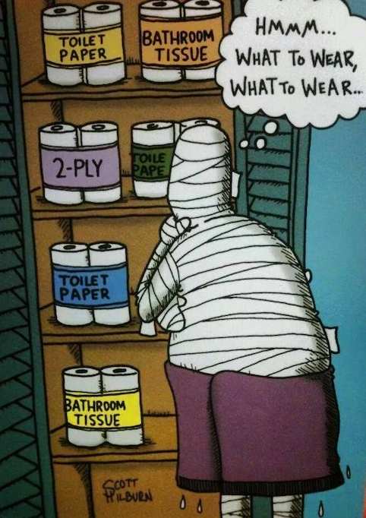

This week was pretty wild! We hope you are finding time to rest and recharge on your days off (and of course get ready for Halloween!).
You are amazing and we appreciate you all very much.

