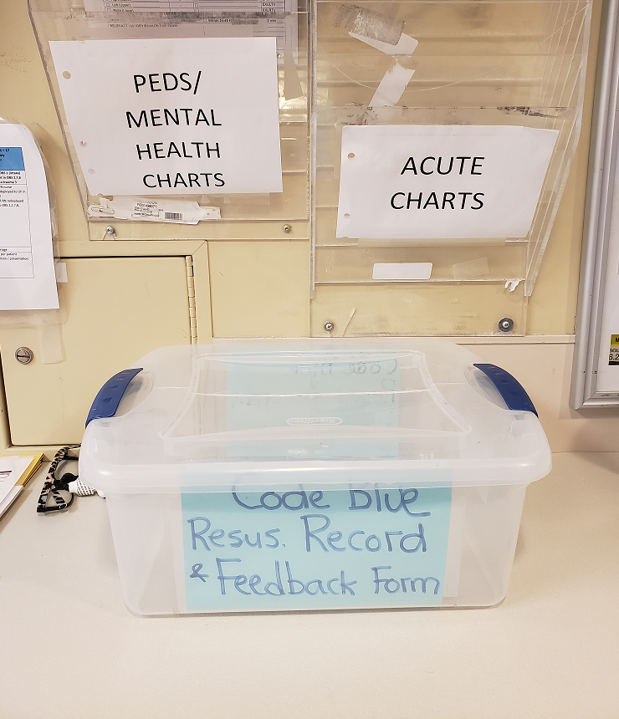

Code Blue Records and Audit Tools
Call for Old Androids

If you have an old android that you no longer use and are willing to donate to our NOISE REDUCTION PROJECT for Housekeeping we would be very grateful. We are looking for ANDROID cell phones 2015 or newer.

We would like to go live with cell phone chat group communication for the housekeepers in the department and need one more phone if possible to make this work.

We need to collect Code Blue records and Audit tools.

These used to go to the ICU CNE’s for auditing, but now Abby and Martha will be able to do it.

Please place them in the bin located in the EP hall under the chart rack.

These audits and tools allow us to fix issues, but also help us ensure that our Code blues are counted in regional statistics – something that can be important when staffing decisions are made.

Summing up the pandemic
April 6th we will go-live with the next phase of the Noise Reduction Project.
Next week Housekeepers will start to carry cell phones and will be looped into a group chat on signal similar to what is currently used to communicate with our HCA’s. This will allow us to communicate with them and improve communication within their group.

A few suggestions:
Please use voice memo function to communicate with housekeepers.
Please be patient when waiting for them to respond. We don’t want them to have to stop what they are doing and remove PPE to respond if they are in the middle of a clean.
If you need housekeeping urgently and aren’t getting a response please page them overhead.
Our regular housekeepers include Selina, Harpreet, Amandeep, and Ritesh with casuals supplementing at times.

Combined PVPC and ATR refresher course is now online!
No virtual classroom component - meaning you can start and
finish it whenever fits for you!

Course code is: 23443

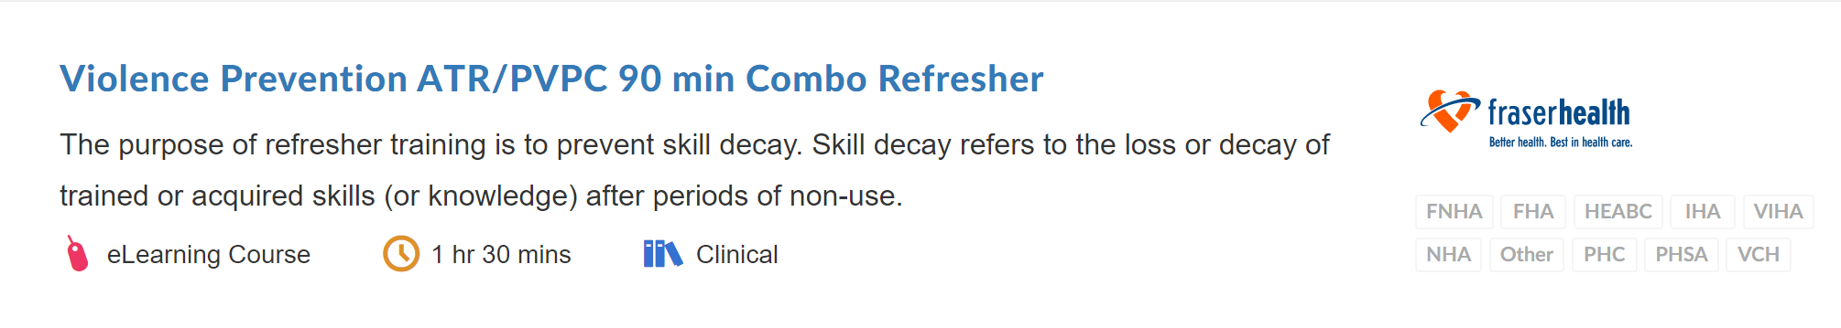


Drs Ahn and Merth will be hosting a US Guided PIV Insertion course on May 27th from 1230-1430.

Please contact Abby or Martha if you are interested in attending.
We can only send 6 staff members but can pay you at straight time for attending this session.

The Pediatric Early Warning System (PEWS) has been in use in FH ED’s for several years.

Complete the PEWS Refresher Course to be entered into a draw for a Pediatric Nursing Gift Basket! Learning Hub Course Code: 19005

Please submit your completion certificate to Abby or Martha to be entered in the draw which will occur in early June.
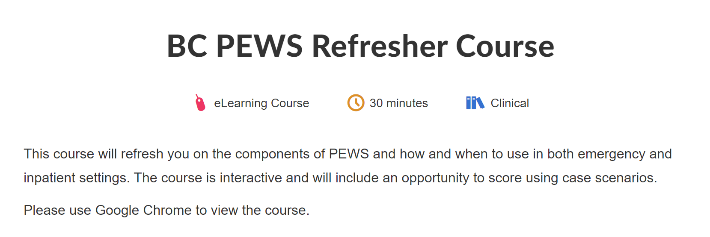
There has been a minor update to the Vaccination Status forms currently included in patient charts on orange paper.

This is to include a place for you to add your name and email address if you complete the form – to be entered in draws for some prizes!

For now, we will continue to use the old version (to save some trees because they are already printed), but please add your name and email address at the bottom if you want to be entered into the draw!
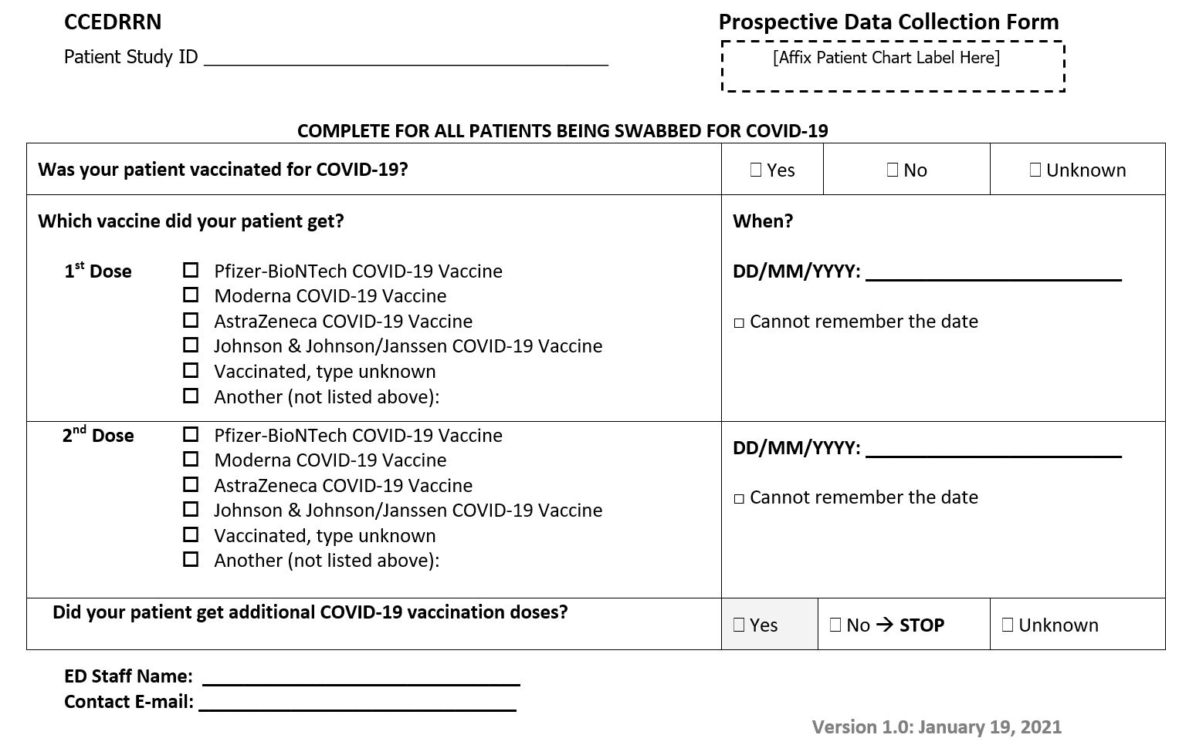

Recent cases to celebrate ☺

Last week: 62 year old male presenting with L sided weakness, drooling and slurred speech suffered a R MCA stroke. Door to needle for tPA 16 minutes. Remains admitted upstairs for stroke work up and has mild deficits.

Earlier this month: 79 year old male presented with TIA, fully resolved upon EHS arrival and not run as hot stroke. 1.5 hours later, primary RN noticed deficits returning. STAT CT done and tPA infusing 27 minutes later and patient subsequently taken to IR for EVT. Patient was just discharged back home on Friday with no deficits.

Earlier this month: 33 year old male with R sided weakness and headache. Diagnosed with hypertensive emergency resulting in brainstem bleed, subsequently sent to HAU and aggressive BP control/management. Receiving rehab at Queen’s Park.

Amazing work everyone…thanks to communication, observations, teamwork!



STROKE UPDATE
SUSAT referrals at RCH have been going well – thank you for your amazing work! Recently we have seen a bit of a decreasing trend in numbers referred.

Please continue to refer people with substance use issues to SUSAT, even if you are also referring to the RAAC clinic (located in the MHWC and open to walk-in patients – pamphlets available from social workers and at the PCC desk).

You do not need consent to enter a SUSAT referral if the patient uses street drugs, but you do need consent if it is for alcohol use.

The SUSAT team can also help with people who are homeless and need to isolate due to COVID symptoms. Go Team!

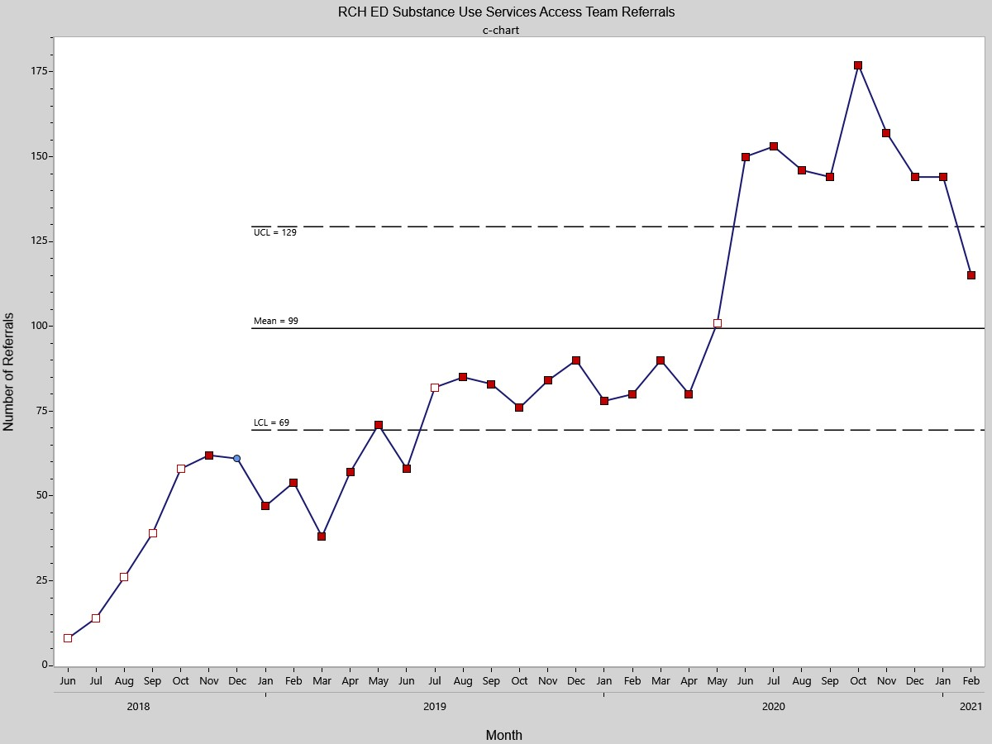

Flu season is over! We no longer need to order flu, COVID and RSV testing on all admitted patients, just COVID tests are needed now. Please see details below.

For ICU and HAU patient testing, please do the blue bag expedited tests to ensure these are processed rapidly.
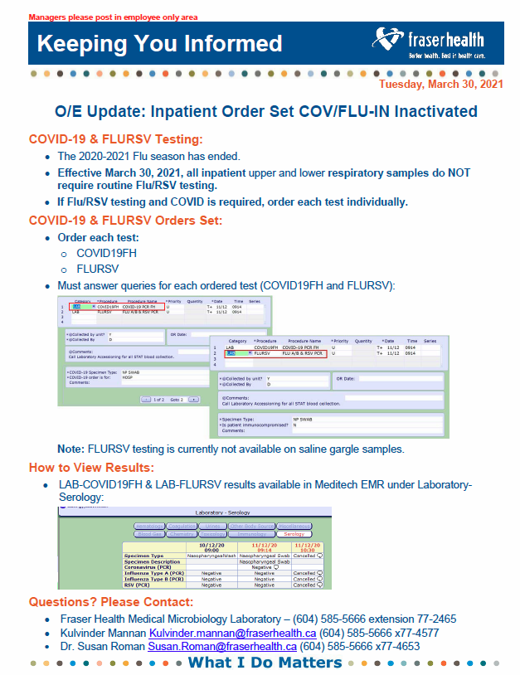

TXA/CBI Research Update!

We are 2 months into the study and have already recruited a total of 7 participants (5 at RCH and 2 at ERH)! We are on track to meet our goal of 20 participants by August 31st. Thank you to everyone who is making this a success. This study takes an entire Emergency Department team and a lot of collaboration- thank you!

A few reminders, there is always an on-call RN available to help out. The on-call schedule and all of the study paperwork can be found at the triage station. Any patient needing a CBI who is in the emergency department should be considered for the study. We can recruit admitted patients who are being held in the ED and patients who initially didn’t present with urinary complaints but were found to need a CBI later in the ED stay. A more detailed list of inclusion and exclusion criteria can be found in the study documents at the triage station.

If you have any questions/concerns or what to be more involved with the study, please feel free to reach out to me directly. kellysoros@outlook.com or 778 230 1053.

